MEDIA ADVISORY – RELEASE IMMEDIATELY
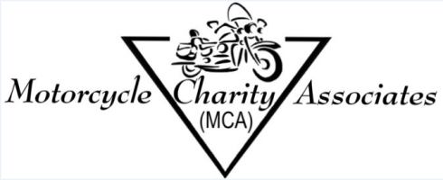
CONTACT:
Executive Director
Motorcycle Charity Associates, Inc. 501(c)(3)
5621 Littler Drive
Huntington Beach, CA 92649
Info@MotorcycleCharityAssociates.org

BOOK RELEASE: "FUN CYCLE"
SPECIAL EDITION FOR THE 75TH ANNIVERSARY OF
THE WORLD'S LEADING MOTORCYCLE RALLY
SUPPORTING: Motorcycle Charity Associates Inc.

WHAT: ONE MILLION PEOPLE, or more, are expected to attend the 75th Anniversary of a Motorcycle Rally in Sturgis, South Dakota August 3-9, 2015. The Book, Fun Cycle, is to explain, exhibit, and enlighten one's understanding of this Mother of all motorcycle gatherings. Fun Cycle guides the reader down a path ingrained in America's popular culture. The author includes memoirs from the 50th Anniversary, when the Rally went from under 100K to over 500K in attendance. Where's it all headed? Has it peaked, is it continuing to grow, another game changer, or was it just, a fun cycle?
A fun read and a fun ride.

WHY: General Public, Motorcycle Enthusiasts, Motorcycle Industry Professionals, want to know. Proceeds go to Charity. Motorcycle Enthusiasts are everywhere! Now more than ever. You don't need a bike to be one, see one, or hear one ride by. Every state, every country, and towns around the world, hold regular motorcycle enthusiast events. Many have raised significant funds for charity. Activities include: races, bike shows, entertainment, games, parades, beauty contests, and much more. The economy gets a boost in areas such as retail, goods and services, rental properties, and tourism.

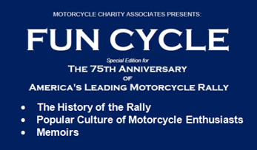
WHO:
Author: Billy Gordon
Motorcycle Charity Associates, Inc.501(c)(3)
Related websites:
www.Fun-Cycle.org
www.MotorcycleCharity.org
www.MotorcycleEntertain.com
www.MotorcycleCharityAssociates.org
www.VIPRide.net
Watch: approx.1 minute YouTube:
Link to high resolution book cover
http://motorcyclecharity.org/FCCover18C.jpg
Story about the book Fun Cycle -
https://youtu.be/nvLaS43A74Y

WHERE: Most Outlets or
EBook Amazon Kindle http://www.amazon.com/dp/B00VU5UBF8
EBook Barns & Noble http://www.barnesandnoble.com/w/fun-cycle-special-edition-for-the-75th-anniversary-of-americas-leading-motorcycle-rally-billy-gordon/1121104795?ean=9781783017225%20#sthash.S1syxusb.dpuf
Amazon Print 6X9 ISBN# 978-1505813814 https://www.createspace.com/Preview/1168041
Amazon Print 8½X11 ISBN# 978-1505555196 https://www.createspace.com/Preview/1160863

MCA Mission: To produce and promote events, sharing the common goal of supporting worthwhile 501(c)(3) charities in research, education, community programs, health services and advocacy efforts.

